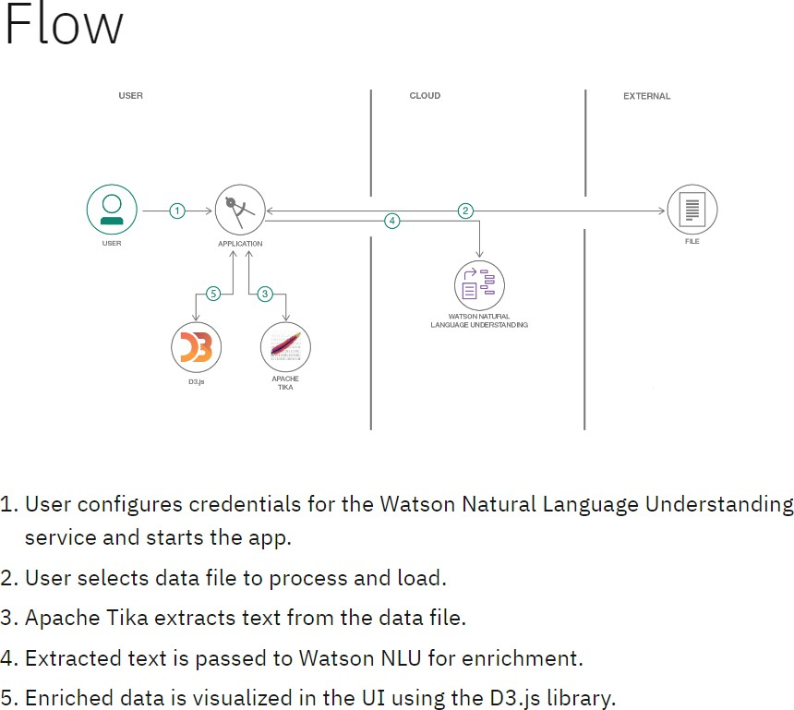
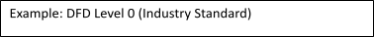
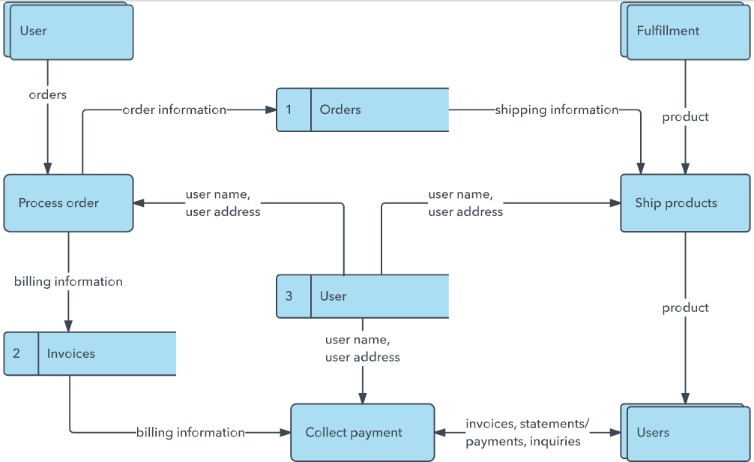
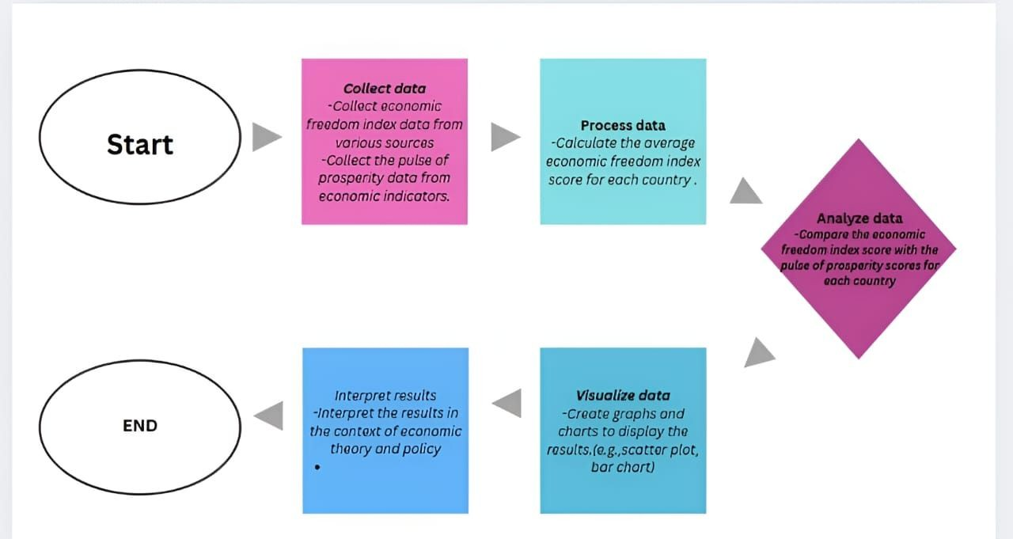
Project Design Phase-II

Data Flow Diagram & User Stories

Date | 20 february 2026
Team ID | LTVIP2026TMIDS72915
Project Name | Measuring the Pulse of Prosperity: An Index of Economic Freedom Analysis
Maximum Marks | 4 Marks

Data Flow Diagrams:
A Data Flow Diagram (DFD) is a traditional visual representation of the information flows within a system. A neat and clear DFD can depict the right amount of the system requirement graphically. It shows how data enters and leaves the system, what changes the information, and where data is stored.
Example: (Simplified)

User Stories
Use the below template to list all the user stories for the product.

User Type | Functional Requirement (Epic) | User Story Number | User Story / Task | Acceptance criteria | Priority | Release
Customer (Mobile user) | Registration | USN-1 | As a user, I can register for the application by entering my email, password, and confirming  my password. | I can access my account / dashboard after successful registration | High | Sprint-1
 |  | USN-2 | As a user, I will receive confirmation email once I have registered for the application | I can receive confirmation email & click confirm | High | Sprint-1
 |  | USN-3 | As a user, I can register for the application through Facebook | I can register & access the dashboard with Facebook Login | Low | Sprint-2
 |  | USN-4 | As a user, I can register for the application through Gmail |  | Medium | Sprint-1
 | Login | USN-5 | As a user, I can log into the application by  entering email & password |  | High | Sprint-1
 | Dashboard
Customer (Web user)
Customer Care
Executive
Administrator

